Nama : Qoridani Choirunnisa
NIM : 24.01.53.6005
Tugas TESTING API NORTH WIND
- GET ALL CUSTOMER AND DETAIL CUSTOMER
Url : http://127.0.0.1/apiphp/api.php/recors/customers
METHOD : GET
PIC :
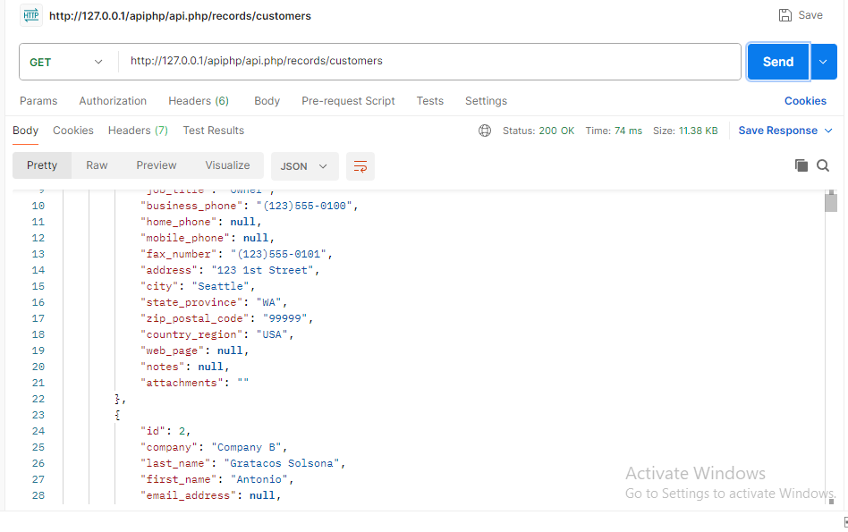
- GET CUSTOMER AND DETAIL CUSTOMER BY ID
URL : http://127.0.0.1/apiphp/api.php/records/customers/1
METHOD : GET
PIC :
